Module 2

Precision Turning (Advanced)

Being able to make your robot avoid obstacles and navigate a maze means the robot needs to know what direction it is facing at all times. In this module you will create a gyro program with a visual feedback to find out how precise your robot can turn.

# Variables

It is important to use variables for values in your program that can change.

## Tutorial

Follow the tutorial Robot Educator 🡪 Beyond Basics 🡪 Variables.

This will teach you how to use variables. By creating a program that will store the number of times you press the touch sensor and move that many rotations forward.

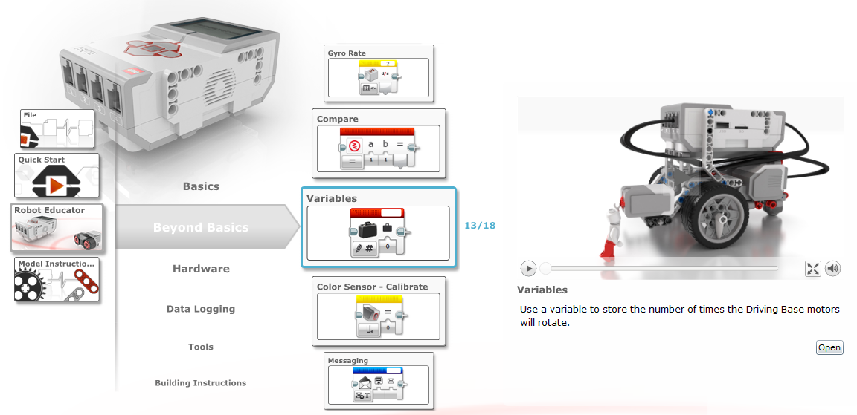

## Initialising Variables

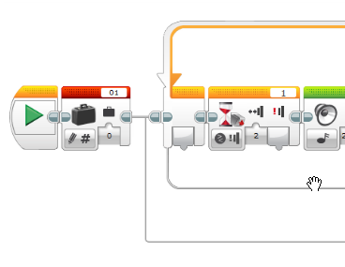In the variables tutorial you will notice at the start of the program the variable “01” is set to 0.

It is good practice to initialise your variables at the start of your program.

# Activity

Create your program to turn your robot with gyro precision.

## Step 1 – Turning

Make your robot turn in the spot either left or right, forever.

*Hint: It will be easier later on if you use the move steering block.*

## Step 2 – Gyro

Use the gyro sensor block and a compare data operations block to perform logic inside the loop to exit the loop.

## Step 3 – Variables

You will need a few variables for your program to run. Here is a list of recommended variables:

* Angle (the angle you want the robot to turn to)
* Steering (the value for steering on the move steering block, left or right)
* Turn Left(a Boolean value for you to define whether to turn left or not)

## Step 4 – Layout

Below is an example of how you can layout your program.

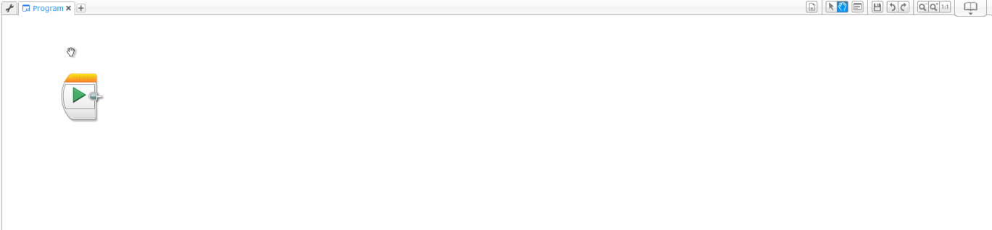

Initialise Variables

Set Turning Direction

Loop –

* Turn
* Test Angle
* Show Value

Stop Motors and Wait

## Step 5 – Show the Angle

Add a text block in the loop to show the current angle of the gyro sensor on the screen.

### Optional

Use the Data Operations – Text block to combine a label for the number being displayed on the screen. Example:

Angle: 45

## Step 6 – Add Left and Right

You should be able to tell the robot to turn left or right. Use your “Turn Left” variable with a switch to define the steering either left or right. Than use the read variable block and wire it into the steering value on the move steering block.

*Hint: The Gyro value becomes negative when the robot turns left. Use the Math block and from the menu select “Absolute Value”. This will make all values positive and you can always compare with less than (<).*

## Step 7 – Accuracy

Add the wait block at the end of your program so you can see if your robot stopped exactly on the right number.

## Complete

Your robot needs to stop on the same number 5 times in a row for you to complete this module.

If your robot isn’t stopping on the right number, try adding a math block in to adjust the angle variable to get what you want.